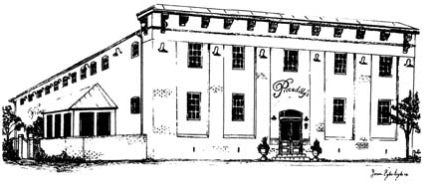
Piccadilly’s
Public House & Restaurant
Tour Group – Plated Dinner Menu
Menu Options - $34.95 Per Person (Includes Tax and Gratuity)
We Must Have a Final Count of Each Entrée 24 Hours in Advance
All Entrees Served with a Side Salad
Garlic Mashed Potatoes, & Vegetable Medley
Coffee, Tea, or Soda & Chef’s Choice Dessert

NEW YORK STRIP
10oz Locally Raised Beef
Hand Cut & Grilled to Perfection

GEORGIA FRIED CHICKEN
Crispy Seasoned Fried Chicken Breast

BOURBON-TERIYAKI SALMON
Seared and Finished in a Sweet and Savory Glaze

MARYLAND CRAB CAKE
One Jumbo Lump Crab Cake
with Just Enough Filler to Hold Together

VEGETARIAN PASTA PRIMAVERA
Penne with Sauteed Vegetables in a Light Sauce
Served with Garlic Bread (No Side)

125 East Piccadilly Street Winchester, Virginia 22601
Reservations: 540-535-1899 ext. 4
Carol Massey
Special Events Manager
carolb@piccadillysevents.com
www.piccadillypublichouse.com

