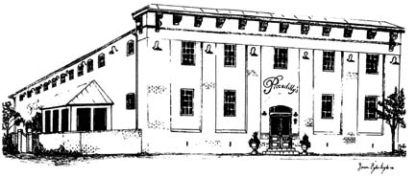
Piccadilly’s
Public House & Restaurant
Tour Group – Plated Dinner Menu

Menu Options
We Must Have a Final Count of Each Entrée 48 Hours in Advance

All Entrees Served with a Side Salad
Garlic Mashed Potatoes, & Vegetable Medley
(Pasta entrée served with salad only)
Coffee, Tea, or Soda & Chef’s Choice Dessert

NEW YORK STRIP
Hand Cut & Grilled to Perfection

HERB GRILLED CHICKEN BREAST
Topped with Dijon Supreme Sauce

BOURBON GLAZED SALMON
Seared and Finished in a Sweet and Savory Glaze

VEGETARIAN OPTION
PASTA PRIMAVERA

$38.00 Per Person (Includes Tax and Gratuity)

125 East Piccadilly Street Winchester, Virginia 22601
Reservations: 540-535-1899 ext. 104
Nannette Boden – Special Events

