Piccadilly’s
Public House & Restaurant
2023-2024 Banquet and Catering Menu
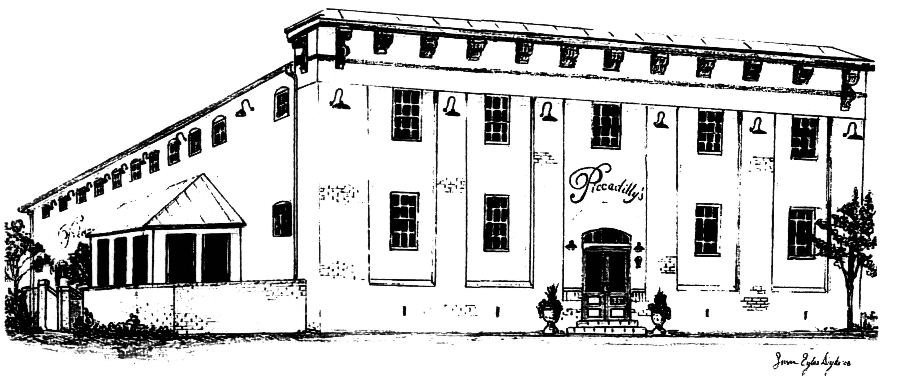

Thank you for considering Piccadilly’s Public House and Restaurant as a location for your next Special Event! Our Two Private Rooms are available for any occasion and can entertain parties for over 200 Guests! We invite you to look over the information listed below and contact us for a private showing and consultation for your upcoming event! Thank you!

Special Event Coordinator
Nannette Boden 540.244.4269 Cell
540-535-1899 ext.104 - nannetteb@piccadillysevents.com

Winchester Room
$750.00
(Up to 152 Guests Seated or 200 Guests Standing Room with Limited Seating)

Loft Dining Room
$350.00
(Up to 64 Guests Seated or 100 Guests Standing Room with Limited Seating)

Winchester Room & Loft
$1000.00
(200+ Guests Seated or 300 Guests Standing Room with Limited Seating)

Swimley’s Piano Bar
$250.00
(Up to 50 Guests Seated or 100 Guests Standing Room with Limited Seating)
(Table Linens for Dining Tables and Booth Tables are at an Additional Cost)
Rental Includes:
Exclusive Use of Room (4 Hours)
Tables and Chairs
Flatware, Stemware & China
Crystal Sugar Caddies
Tower Salt and Pepper
Utility Tables
Food Chafers
Serving Utensils
Cloth Napkins
Table Linens, Linen Napkins and Table Skirting with Lighting**
Linen Napkins and Table Skirting with Lighting**
Use of our PA system (Winchester Room Only)
Dance Floor (Winchester Room Only)
Full Bar (Winchester Room Only)
Private Facilities for Guests

Event Service Charge:
This service charge includes Set-up and Clean-up of your room, Chef, Kitchen Staff,
Servers and Bartenders, as well as an Event Coordinator to oversee the Event & your Selected Vendors.

The service charge is $5.00 per person to a maximum of $500.00.

**Includes White Linens and Settings, Other Colors and Specialty Rentals are available through an outside linen vendor. Ask Your Special Events Coordinator for more information.

Hors D’oeuvres:
$3.25 per Guest for one of the following
Route 11 Chips, Pretzels, and Nuts (3oz)
Cucumber & Cherry Tomato Salad Tartlets (2pcs)
Cheese Tortellini in Marinara or Alfredo Sauce (4oz)
Fresh Vegetable Crudité with Spinach or Ranch Dip (3oz)
Bruschetta with Crostini - Tomato, Portobello, Basil, and Red Onion (2pcs)
Cocktail Meatballs Served in Barbeque, Marinara, Swedish, or Sweet & Sour Sauce (5pcs)

$4.25 per Guest for one of the following
Fresh Fruit Platter with Berry Yogurt Dipping Sauce (4oz)
Roasted Vegetable Platter with Sea Salt and Balsamic Reduction (3oz)
Caprese Salad Skewers - Cherry Tomato, Basil, and Fresh Mozzarella (2pcs)
Spanakopita - Phyllo Dough filled with Spinach, Onion, and Feta Cheese (2pcs)
Domestic & Import Cube Cheese Platter with Grapes and Crackers (4oz)

$5.25 per Guest for one of the following
Pigs in a Blanket (2pcs)
Coconut Shrimp with Sweet Chili Dip (2pcs)
Creamy Crab Dip with Baguette Slices (4oz)
Asian Spiced Chicken Sate Served with Thai Peanut Sauce (3pcs)

$6.25 per Guest for one of the following
Mini Crab Cakes with Tartar Sauce (2pcs)
Chilled Jumbo Shrimp Cocktail with Cocktail Sauce (2pcs)
Filet Toast Points with Horseradish Cream and Roasted Cherry Tomatoes (2pcs)
***Bacon Wrapped Scallops - Skewered Sea Scallops Wrapped in Crisp Bacon (2pcs)
Beef Kabob - Marinated Sirloin Tips with Peppers & Onion on Wooden Skewers (2pcs)
Piccadilly’s Wings with Sauce Carousel, Ranch, Blue Cheese & Celery (3pcs)

Try an Hors D’oeuvre Reception
$17.95/Guest – Choose One Item per Pricing Group
$26.95/Guest – Choose any Six Items (At Least One Per Pricing Group)
These Menus Include Complimentary Coffee, Tea, and Soda for Your Guests

Smoked Salmon Platter – House Smoked and Served with Red Onion, Capers, Lemon,
Herb Cream Cheese Spread, Horseradish and Crispy Flatbread - $175.00 (Serves 40 Guests)

*** If a price increase or substitution is necessary, due to demand or market pricing, the Event Coordinator will notify you beforehand.

Standard gratuity of 20% will be added to all food and beverage totals. Prices are based on today’s market & are subject to change.

Buffet Dinner Menu
Listed below are our current menu options.
Our staff can help you select a customized Event Menu based on your needs.
Complimentary Coffee, Tea, and Soda included with Buffet at no additional charge.

$22.95/Guest – Choose Two Entrees, Two Accompaniments and One Salad
$27.95/Guest- Chose Three Entrees, Two Accompaniments and One Salad
Additional Accompaniments or Salad add $3.00.

Entrees:
Barbeque Chicken Breast Topped with Bacon, Cheddar & BBQ Sauce
Herb Grilled Chicken Breast with Sun Dried Tomato Basil Cream Sauce
Grilled Chicken with Supreme Dijon Sauce
Blackened Chicken Breast with Creole Sauce

Hand Pulled Pork Barbeque
Honey-Pineapple Glazed Ham
Candied-Bacon Wrapped Pork Tenderloin
Smoked Pork Tenderloin with Caramelized Onions and BBQ Sauce

Tortellini Alfredo with Jumbo Shrimp
Soy and Ginger Marinated Salmon (add $2.00)
Fennel Crusted Salmon with Shallot Cream Sauce (add $2.00)
Crab Imperial Stuffed Filet of Tilapia with Shallot Cream Sauce

House Marinated London Broil
Sliced Roast Beef Sirloin with Brandied Peppercorn Sauce
Sliced Roast Beef Sirloin with Mushroom and Garlic Demi-Glaze
Sliced Prime Rib in Au Jus with Horseradish Cream on the Side (add $4.00)
Beef Filet Medallions with Tomato Au Jus (add $4.00)

Eggplant Parmesan
Baked Ziti with Meat Sauce or Vegetarian
Meat or Vegetable Lasagna with Marinara or Alfredo Sauce
Mushroom Ravioli on Wilted Leeks with Brandy Au Jus

A standard gratuity of 20% will be added to all food and beverage totals.
Prices are based on today’s market and are subject to change.

Accompaniments:
Herb Mashed Potatoes
Mashed Sweet Potatoes
Classic Garlic Mashed Potatoes
Sour Cream and Cheddar Mashed Potatoes
Mashed Potato Bar with Assorted Toppings (add $3.00)
Mashed Sweet Potato with Assorted Toppings (add $3.00)
Garlic Roasted Red Potatoes
Parmesan Roasted Red Potatoes
Au Gratin Potatoes with Mozzarella

Wild Rice Pilaf
Basil Pesto Risotto
Brown Butter, Cranberries & Pecan Rice

Blistered Asparagus
Squash and Zucchini Medley
Italian Style Green Beans (Garlic, Oil, White Onion)
Country Style Green Beans (Bacon, Butter, Red Onion)

Salad Selections:
Classic Caesar Salad with Croutons and Parmesan Cheese

Tossed Garden Green Salad with Ranch and Balsamic Vinaigrette

Spinach Salad with Mandarin Oranges, Red Onion, Feta
Strawberries and Slivered Almonds with Raspberry Vinaigrette (add $1.00)

George Washington Salad –Spring Mix, Cranberries, Spiced Pecans
and Bleu Cheese Crumbles with Balsamic Vinaigrette on the Side (add $2.00)

Greek Salad with Baby Field Greens, Tomatoes, Cucumbers, Red Onion,
Green Peppers, Feta Cheese and Kalamata Olives tossed in Red Wine Vinaigrette (add $2.00)

Salad Bar with Romaine Lettuce, Mixed Greens, Tomato, Cucumber, Carrots, Onion,
Croutons, Shredded Cheddar-Jack, Shredded Parmesan, and Assorted Dressings (add $3.00)

Add Meatballs and a Cheese Display to Any Full Buffet Dinner For $6.50 per Guest

A standard gratuity of 20% will be added to all food and beverage totals.
Prices are based on today’s market and are subject to change.

Additional Selections

Cold Salad Selections:
Cole Slaw $2.00
Potato Salad $2.00
Fresh Fruit Salad $3.00
Italian Pasta Salad $3.00

Soups:
Curried Carrot $3.00
Chicken Noodle $3.00
Beef and Vegetable $3.00
Cream of Mushroom $3.00
Tomato, Basil & Roasted Red Pepper $3.00
Butternut Squash & Apple $3.00
Shrimp & Lobster $6.00

Desserts:
Chef’s Choice $5.25
Assorted Pies $4.25
Assorted Buffet Cakes $5.25
New York Cheesecake $5.00 Additional Toppings $1.25
Assorted Flavored Cheesecake $5.75
Chocolate or Carrot Cake $5.25
Fresh Baked Fruit Cobbler $4.25
Sticky Toffee Pudding Cake $4.25
Bourbon-Caramel Bread Pudding $4.25
Chocolate Dipped Strawberries (2pcs) $5.25
Chocolate Fountain with Fresh Fruit and Pound Cake $7.00 (Min. 40 Servings)

A standard gratuity of 20% will be added to all food and beverage totals.
Prices are based on today’s market and are subject to change.

Piccadilly’s Brunch Menu
Available for Events Between 11:30am and 4:00pm
$19.95 per Guest
Includes the Following Items Plus
Complimentary Coffee, Tea, and Soda

Includes:
Bacon Strips
Sausage Links
Scrambled Eggs
French Toast with Butter and Syrup

Choose One Salad Item
Fresh Fruit Salad with Yogurt Dip
Classic Caesar Salad with Croutons and Parmesan Cheese
Tossed Garden Salad with Ranch and Balsamic Vinaigrette
Spinach with Mandarins, Red Onion, Strawberries, Feta, Almonds, and Raspberry Vinaigrette

Choose One Entrée Item
Tortellini Alfredo – Plain or with Chicken
Herb Grilled Chicken with Choice of Sauce
Crab Stuffed Tilapia in Shallot Cream Sauce
Sliced Sirloin in Au Jus with Horseradish Cream

Optional Additions
Eggs Benedict (add $5.00)
Assorted Muffins (add $3.00)
Second Salad Option (add $2.00)
Second Entrée Option (add $5.00)

Orange, Cranberry and Pineapple Juice (add $1.00)
Mimosa Bar (Alcohol Based on Consumption)
Bloody Mary Bar (Alcohol Based on Consumption)

Additional Selections May Be Made a La Carte
Please Ask Your Special Events Coordinator for more information.
A standard gratuity of 20% will be added to all food and beverage totals.
Prices are based on today’s market and are subject to change.

Piccadilly’s Lunch Menu
Available for Events Between 11:30am and 4:00pm
Each Menu served with Complimentary Coffee, Tea, and Soda

Choose One Entrée, One Salad and 2 Sides from the Dinner Menu
Includes Bread and Butter
$17.95 per Guest

Or

Assorted Sandwiches and/or Wraps, Your Choice of Salad and Two Sides Listed Below
(Sandwiches Include: Ham and Cheddar, Turkey, and Swiss & Chicken Salad,
Vegetarian Options Available Upon Request)
$14.95 per Guest

Salad
Classic Caesar Salad with Croutons and Parmesan Cheese
Tossed Garden Green Salad with Chef’s Choice of Dressing

Sides
Cole Slaw
Fruit Salad
Pasta Salad
Potato Salad
Rt.11 Potato Chips
Soup du Jour (add $2.00)

A standard gratuity of 20% will be added to all food and beverage totals.
Prices are based on today’s market and are subject to change.

Additional Selections May Be Made a La Carte
Please Ask Your Special Events Coordinator for more information.

